**Wayport Assignment**

**Name – Prathmesh Sanjayrao Nikam**

**Registration no. – 2020BCS028**

**Email id –** [**2020bcs028@sggs.ac.in**](mailto:2020bcs028@sggs.ac.in)

**Branch – CSE**

**College – SGGS nanded**

1. **Pull the Neo4j Docker image :   
   command : docker pull neo4j  
   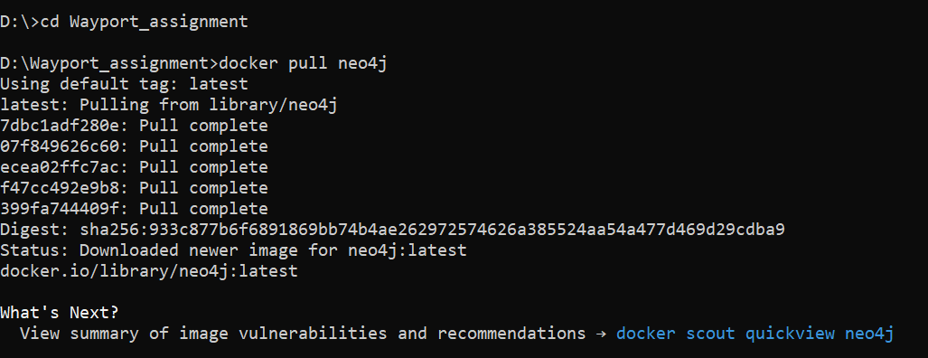**
2. **Created a Docker Container :   
   command : docker run --name neo4j-container -p 7474:7474 -p 7687:7687 -d neo4j  
   **
3. **Access Neo4j Web interface:**

**Navigating to** [**http://localhost:7474**](http://localhost:7474) **on browser**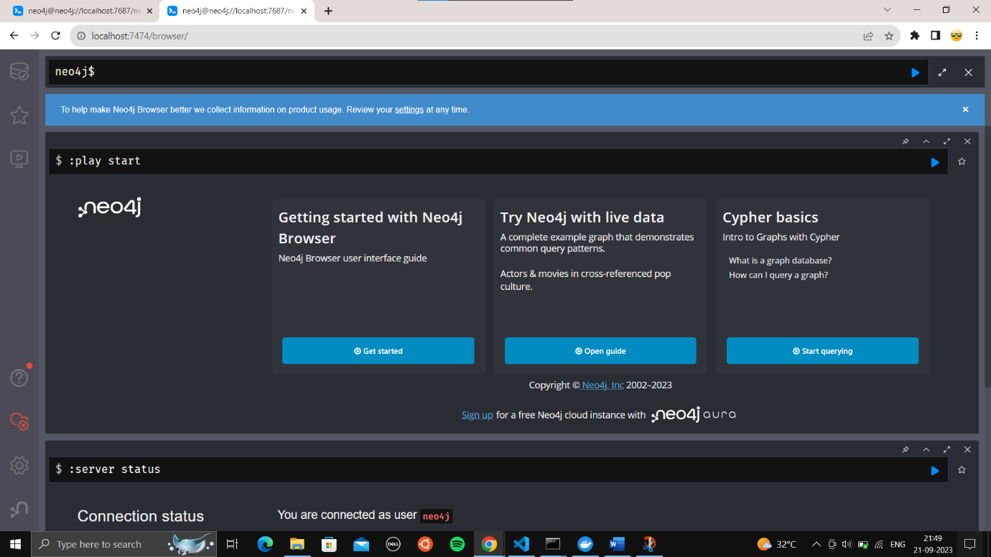

1. **Creating DB instance on docker web server of Neo4j container :  
   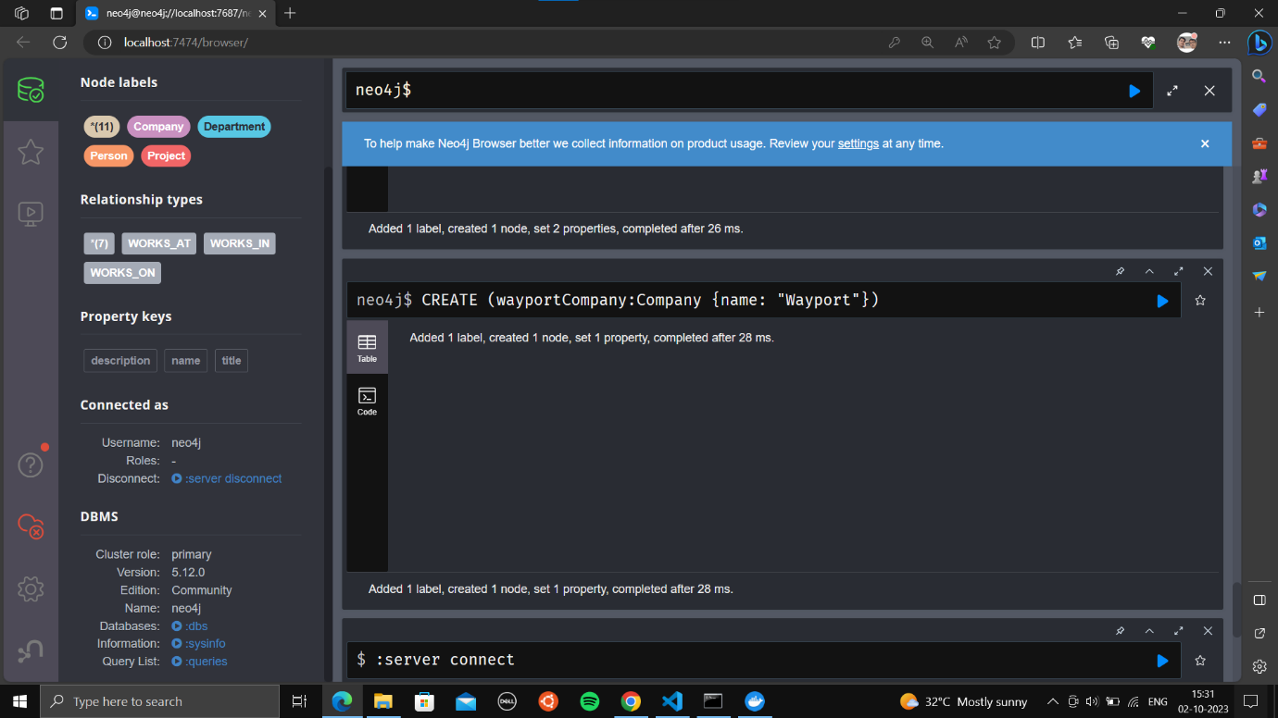**
2. **Visualizing the Graphical view of Database :**

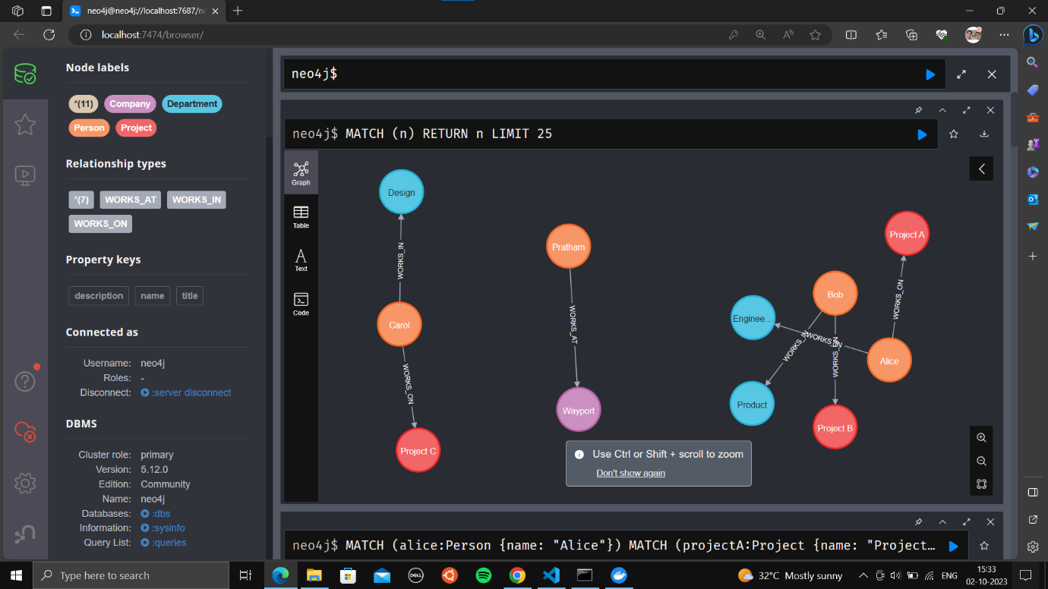

1. **Connecting python server.py file with neo4j DB instance**

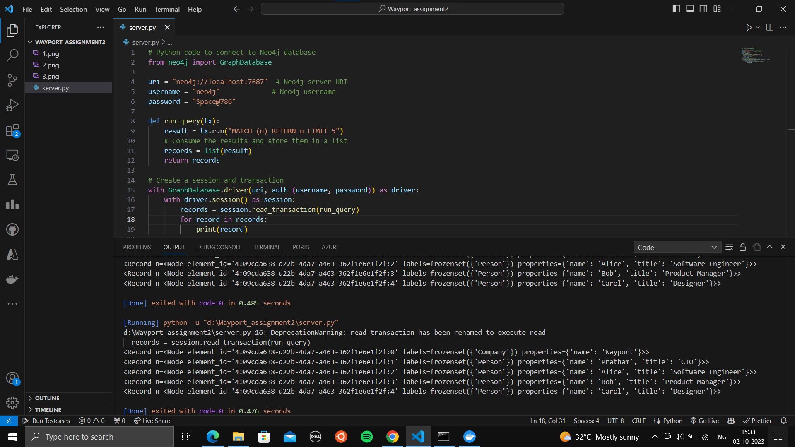

* **Conclusion –**

**Our Python script is now able to successfully query the Neo4j database and print the query results without encountering the "The result is out of scope" error.**

**The output you provided shows the result records returned by your query, which include nodes with labels "Company" and "Person" along with their properties. This indicates that our script is successfully connecting to the Neo4j database, running the Cypher query, and fetching the results.**